User - Manual

Step 1: Compile client.c and server.c in two different terminals by following command
gcc client.c -o client
gcc server.c -o server

Step 2: Run ./client and ./server

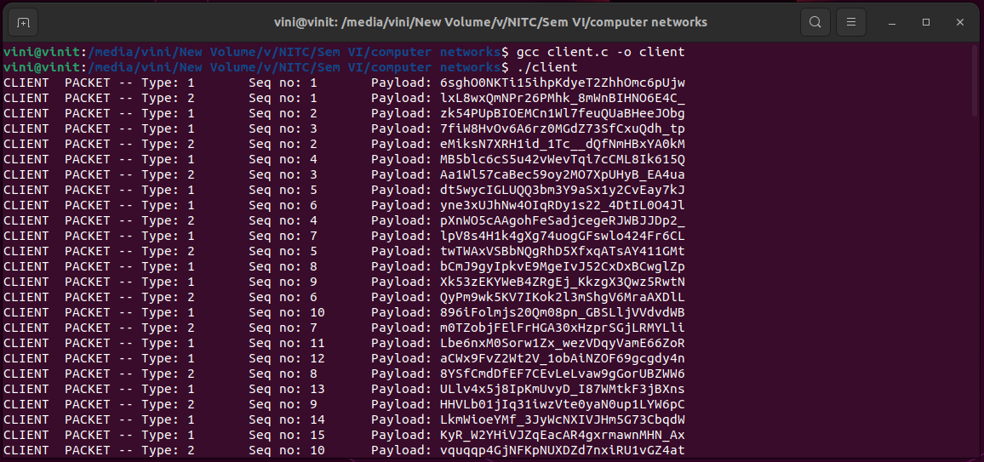

Output on client side:
Continuously printing packets in every 100ms and every 150ms before sending
PACKET – Type, sequence number and payload is being printed

Type: Type of the packet 1Or 2
Sequence number: It is corresponding type sequence number.
Payload: Byte array of 1024 bytes containing randomly generated string of size 20

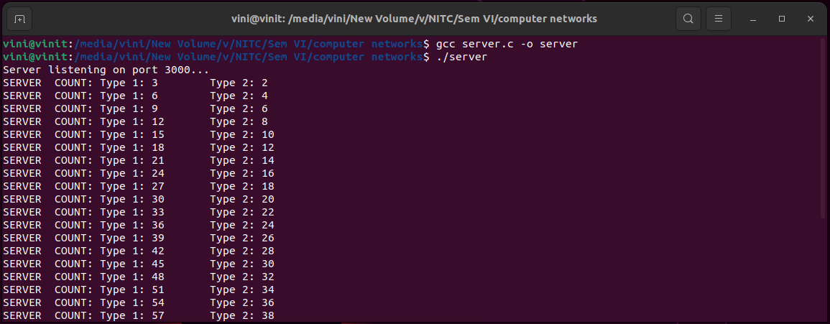

Output on server side:
Printing received packet counts every 300th ms
COUNT: Type 1 count and Type 2 count

If want to print received packet also, then set PRINT_PACKETS to 1 defined in macro.
Set PRINT_PACKETS to 0, to avoid printing packets in server side.

Handling errors on client side
1. “bind failed error”
Open both the code files and change the port number defined at the top in macros as SERVER_PORT
2. “Error sending data”
sendto() function couldn’t send data
Rerun the program
3. “Error creating socket”
socket() function could not create socket
Rerun the program

Handling errors on server side
1. “recvfrom”
recvfrom function failed
Rerun the program
2. “ERROR: Packet checksum not matched”
Packet got corrupted
3. “socket”
Socket creation failed
Rerun the program
4. “bind”
Bind failed
Change the macro-SERVER_PORT in both the files and recompile the code.

